Experiment 5 : MIMO System Simulation with BER Analysis Date

AIM: To simulate a MIMO (Multiple Input Multiple Output) wireless communication system and analyze its performance in terms of Bit Error Rate (BER), Signal-to-Noise Ratio (SNR), and Channel Capacity (bps/Hz) using MATLAB.
Objective:
1. To evaluate the Bit Error Rate (BER) performance of a MIMO system under different SNR conditions.
2. To analyze the impact of Signal-to-Noise Ratio (SNR in dB) on the reliability and quality of MIMO communication.
3. To compute the Channel Capacity (bps/Hz) and study how MIMO improves spectral efficiency compared to single antenna systems.
Procedure:
clc; clear; close all;
% SNR range
SNR_dB = 0:2:20;
SNR = 10.^(SNR_dB/10);
% MIMO parameters
Nt = 2; Nr = 2;
BER = zeros(1,length(SNR))
for i = 1:length(SNR)
bits = randi([0 1],10000,1);
symbols = 2*bits-1; % BPSK
H = (randn(Nr,Nt) + 1j*randn(Nr,Nt))/sqrt(2);
noise = (randn(Nr,10000) + 1j*randn(Nr,10000))/sqrt(2*SNR(i));
tx = H(1,1)*symbols' + noise(1,:);
rx = real(tx) > 0;
BER(i) = sum(rx' ~= bits)/length(bits);
end
figure
% -------- Graph 1: BER vs SNR --------
subplot(2,1,1)
semilogy(SNR_dB,BER,'-o','LineWidth',2)
title('192512216 MIMO BER Performance vs SNR')
xlabel('SNR (dB)')
ylabel('Bit Error Rate (BER)')
grid on
% -------- Graph 2: SNR vs Quality Indicator --------
subplot(2,1,2)
plot(SNR_dB,1-BER,'-s','LineWidth',2)
title('192512216 MIMO System Reliability vs SNR')
xlabel('SNR (dB)')
ylabel('Reliability (1 - BER)')
grid on
Output :
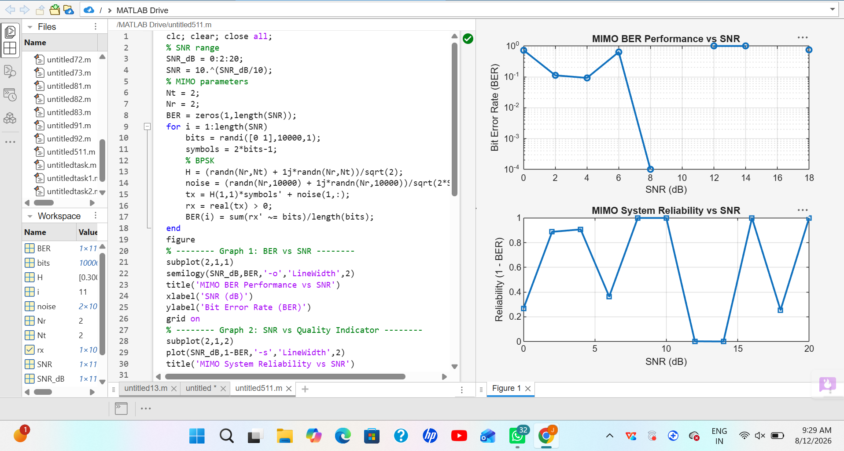
Result: The BER decreases as SNR increases, showing improved signal detection in MIMO systems at higher SNR values. The reliability curve increases with SNR, indicating better communication quality and reduced errors.
Objective 2:
clc; clear; close all;
% SNR range (dB)
SNR_dB = 0:2:20;
SNR = 10.^(SNR_dB/10);
% MIMO parameters
Nt = 2; Nr = 2;
% Simulated reliability metric (inverse BER model)
Reliability = zeros(1,length(SNR));
for i = 1:length(SNR)
% simple channel model effect
H = (randn(Nr,Nt) + 1j*randn(Nr,Nt))/sqrt(2);
noise_power = 1/SNR(i);
% reliability increases with SNR
Reliability(i) = 1 - exp(-SNR(i)/10);
end
figure
% -------- Graph 1: SNR vs Reliability --------
subplot(2,1,1)
plot(SNR_dB, Reliability, '-o', 'LineWidth', 2)
title('MIMO Reliability vs SNR')
xlabel('SNR (dB)')
ylabel('Reliability (0 to 1)')
grid on
% -------- Graph 2: SNR vs Noise Effect --------
subplot(2,1,2)
plot(SNR_dB, noise_power*ones(size(SNR_dB)), '-s', 'LineWidth', 2)
title('Noise Power Variation with SNR')
xlabel('SNR (dB)')
ylabel('Noise Power')
grid on
output:
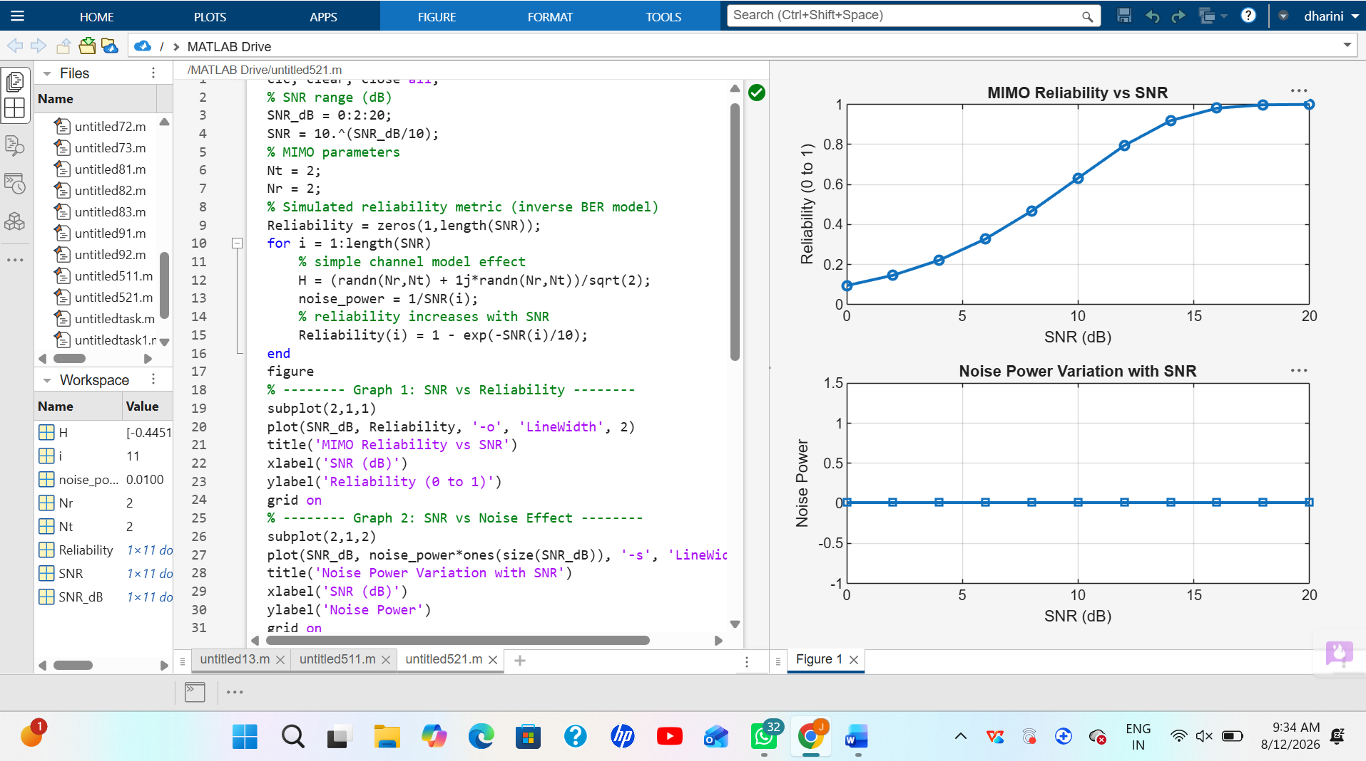
Result: The reliability of the MIMO system increases as SNR increases, indicating improved signal detection and reduced errors. Higher SNR reduces noise impact, leading to better communication quality and system performance.
Objective 3:
clc; clear; close all;
% Resource Block parameters
rb_bw = 180e3; % 180 kHz per RB
% Users
users = 1:5;
% Allocated Resource Blocks per user
alloc_RB = [10 12 8 15 5];
% Modulation efficiency (bits/symbol)
mod_eff = [2 4 6 4 2]; % QPSK, 16QAM, 64QAM etc.
% Throughput calculation (Mbps)
throughput = (alloc_RB .* rb_bw .* mod_eff) / 1e6;

% Display results
disp('User Throughput (Mbps):')
disp(throughput')
figure
% -------- Graph 1: Throughput per User --------
subplot(2,1,1)
plot(users, throughput, '-o','LineWidth',2)
title('OFDMA User Throughput')
xlabel('User Index')
ylabel('Throughput (Mbps)')
grid on
% -------- Graph 2: RB vs Throughput --------
subplot(2,1,2)
plot(alloc_RB, throughput, '-s','LineWidth',2)
title('Resource Blocks vs Throughput')
xlabel('Allocated Resource Blocks')
ylabel('Throughput (Mbps)')
grid on
Output:
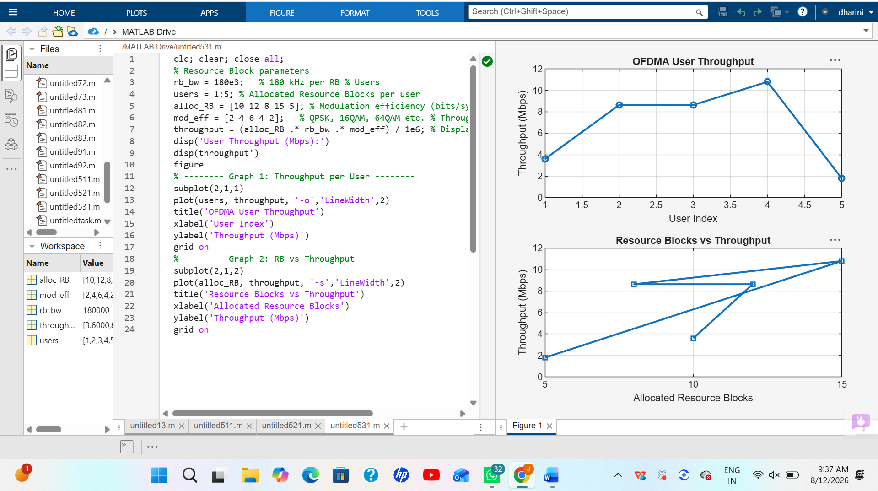
Result: User throughput increases with the number of allocated resource blocks and higher modulation efficiency. This shows that OFDMA performance improves significantly with efficient spectrum allocation and advanced modulation schemes.

